“Early reading, whether it is in a parent’s lap, on the carpet of a classroom, or in a snug reading corner, gently but indelibly imprints upon us the mould from which will cast a lifetime of communication in the world.”
Alex Quigley – Closing the Reading Gap 2020.
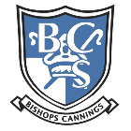
Welcome to the Bishops Cannings Reading Spine. In time, we will be adding upcoming and previous terms.

This reading spine links with our whole school Literacy intent, where during your children’s time at Bishops Cannings they will:

- Receive a high quality curriculum within a literacy rich environment
- Experience a diverse range of texts and have a love of reading
- Able to confidently communicate with others
- Develop independence in their writing skills across a range of genres

It is important to stress that the recommended books for each year group are ideas to help guide the children towards age-appropriate books but also to enhance reading for pleasure. This includes a variety of genres which are important for your child to receive a well-rounded education. We have considered many aspects when compiling this list:

- There is a picture book (in blue) included in each year group, one in Autumn, Summer and Spring term. As your child becomes a more competent reader their decoding and fluency skills improve. Sometimes, in KS2, picture books can be judged as an ‘easy read’ however these books often carry complex themes which help develop children’s inference and prediction skills. They are invaluable for discussion both within and out of the classroom setting. Additionally, there is poetry (in red) included in every term for every year group as well as non-fiction (in green) being included throughout the year. This is because it is important for your children to have access to a wide variety of genres throughout their time in school.
- Research has consistently shown that there is a gender gap in reading attainment with girls outperforming boys. Our list ensures that there are books that will encourage and enthuse both genders.
- Links to our ‘cultural capital’ – exposing our children to different cultures and childhood experiences.
- A reading rich school embraces all our community. We need to work together to inspire our children to engage in the love of reading. We have including a ‘staff recommended reads’ page. These books being ones that we as staff enjoyed reading as children or adults, where we lost ourselves in imaginary, fantastic worlds.

EYFS
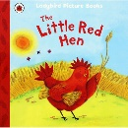  Autumn 1  The Little Red Hen  You Choose  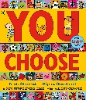  My Body by Discovery World  Creation Story  Maria Montessori  My Special Angels (I)  All Are Welcome (Hum) | Autumn 2  Nursey Rhymes  - Head Shoulders Knees & Toes,  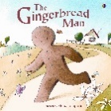  - Number Rhymes (1 finger, 1 thumb – 2 little dicky birds)  - Triangle Song  - Hickory Dickory  - Firework Poem  The Gingerbread Man  Big Book of Celebrations  The Birth of Jesus
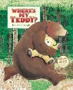  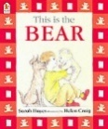  Spring 1  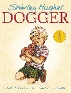  This is the bear/where’s my Teddy?  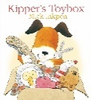  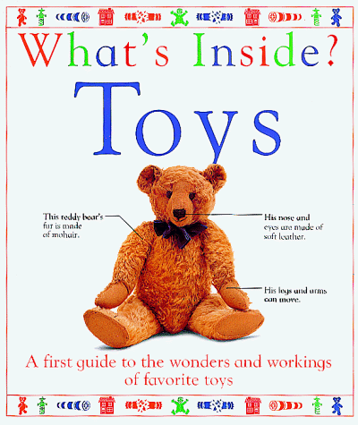  What’s inside toys?  Kipper’s toy box.  Dogger  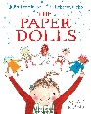  The Paper Dolls  Toys from the Past  Toys from Around the World  The 10 Commandments  Ilyas and Duck (I) | 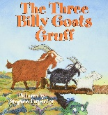  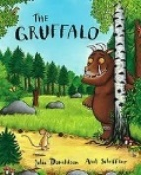  Spring 2  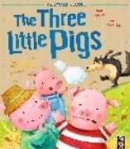  The Gruffalo – Julia Donaldson  The Billy Goats Gruff  The Three Little Pigs  A selection of rhymes linking to Spring.  Palm Sunday
Summer 1  Bean diary/sunflowers  Jack and the Beanstalk  The Life Cycle of a Butterfly  The Very Hungry Caterpillar  Butterfly by David L Harrison  Jesus at the temple  Georgia O’Keefe | 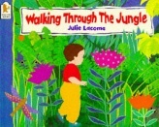  Summer 2  Life in the Rainforest (Topic)  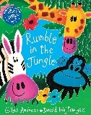  Walking Through the Jungle  Rumble in the Jungle  Conversation with Paul  David Attenborough
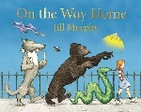
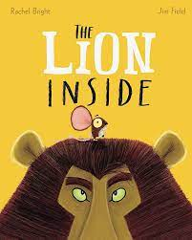
Recommended Reads

Fiction
The Lion Inside – Rachel Bright & Jim Field
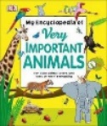
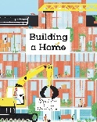
On the Way Home – Jill Murphy

Non-Fiction
Very Important Animals – DK
Building a Home – Polly Faber & Klas Fahlen
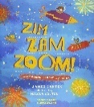
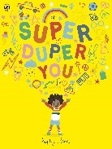
Poetry
Super Duper You – Sophy Henn
Zim Zam Zoom! – James Carter & Nicola Colton

YEAR 1
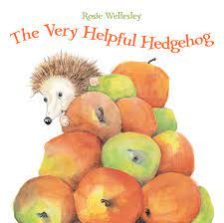  Autumn 1  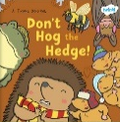  The Very Helpful Hedgehog – Rosie Wellesley  Don’t Hog The Hedge  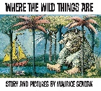  Where the Wild Things Are – Maurice Sendak  The Gunpowder Plot (Selection of Information Texts)  Adam and Eve  It’s a Mitzvah (J) | 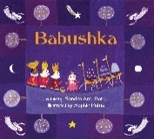  Autumn 2  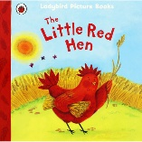  Babushka  The Little Red Hen  Recipe for Bread  The More It Snows – AA Milne  The Magi
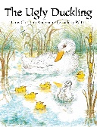  Spring 1  The Ugly Duckling – HC Anderson  Birds (Selection of Non-Fiction Texts)  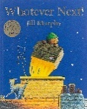  The History of Flight – The Wright Brothers (Selection of Non-Fiction Texts)  Whatever Next! – Jilly Murphy  10 Commandments  Hans Christian Anderson  Florence Nightingale | 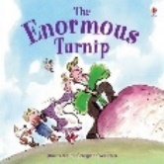  Spring 2  The Enormous Turnip  Sunflower/Cucumber Diary  A selection of Spring poetry (Daffodils).  The cleansing of the temple
Summer 1  Materials (Big Book)  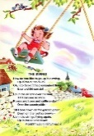  Queen Victoria (Selection of Non-Fiction Texts)  The Swing – RL Stevenson  Jesus begins healing | 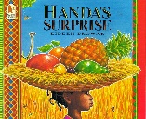  Summer 2  Handa’s Surprise  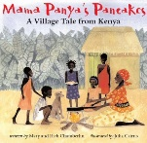  African Animals (Selection of Non-Fiction Texts)  Mama Panya’s Pancakes  The conversion of Paul  Ella Fitzgerald
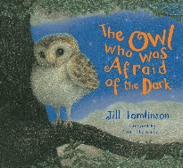
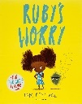
Recommended Reads

Fiction
The Owl Who Was Afraid of the Dark – Jill Tomlinson
Ruby’s Worry – Tom Percival
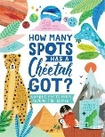
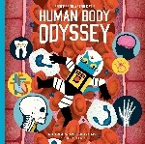
Non-Fiction
How Many Spots has a Cheetah Got? – Steve Martin & Amber Davenport
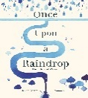
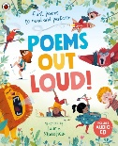
Professor Astro Cat’s Human Body Odyssey – Dominic Walliman & Ben Newman

Poetry
Poems Out Loud – Ladybird & Laurie Stransfield
Once Upon a Raindrop – James Carter and Nomoc
YEAR 2
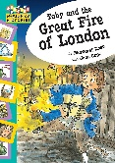  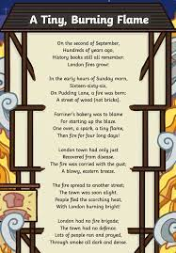  Autumn 1  A Tiny Burning Flame  Toby and the Great Fire of London  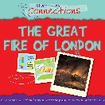  Start-Up Connections - The Great Fire of London  The Beginning (Adam and Eve)  John Lennon | 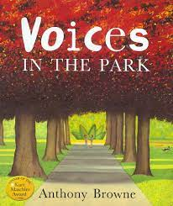  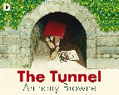  Autumn 2  Variety of Anthony Browne Books  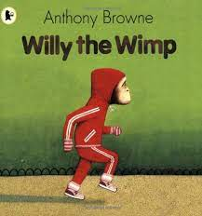  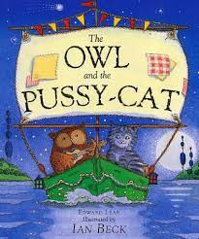  (Tunnel, Voices in the Park, Willy the Wimp etc).  The Owl and the Pussycat  The Shepherds and the Angels  Oskar and the Eight Blessings (J)
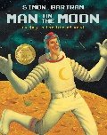  Spring 1  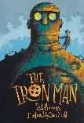  A Day in the Life of Bob (Man on the Moon)  The Iron Man – Ted Hughes  10 Commandments | 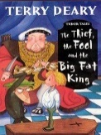  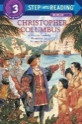  Spring 2  Step into Reading: Christopher Columbus.  The Thief, the Fool, and the Big Fat King – Terry Deary  A selection of sea poetry.  Cleansing of the Temple
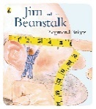  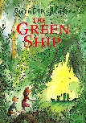  Summer 1  The Green Ship – Quentin Blake  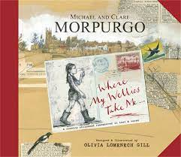  Jim and the Beanstalk – Raymond Briggs  Where My Wellies Take Me – Michael and Clare Morpurgo  Jesus calls his first followers  Pablo Picasso | 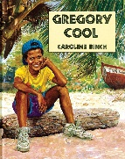  Summer 2  Gregory Cool – Caroline Binch  A Selection of Persuasive Leaflets  A selection of cultural poems  Resurrection  Frida Kahlo
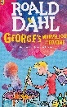
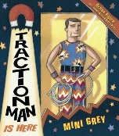
Recommended Reads
Fiction
Traction Man is Here – Mini Grey
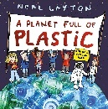
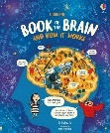
George’s Marvellous Medicine – Roald Dahl & Quentin Blake

Non-Fiction
A Planet Full of Plastic – Neal Layton
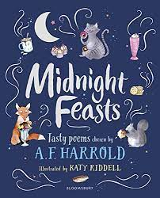
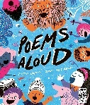
Book of the Brain – Betina Ip & Mia Nilsson

Poetry
Poems Aloud – Joseph Coelho & Daniel Gray-Barnett
Midnight Feasts – A.F Harrold & Katy Riddell

YEAR 3
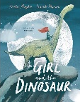  Autumn 1  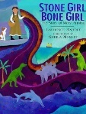  The Girl and the Dinosaur  Stone Girl, Bone Girl  Temptation and the Fall  Mary Anning  Laila’s Lunchbox (I) | 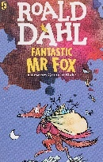  Autumn 2  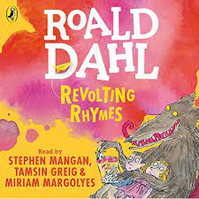  Fantastic Mr Fox  Revolting Rhymes  The Magi
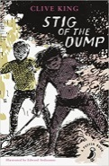  Spring 1  Stig of the Dump – Clive King  A selection of instructional texts.  Mrs Homophone.  Range of other poetry.  7 deadly sins  Mahatma Ghandi | 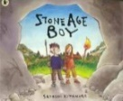  Spring 2  Stig of the Dump – Clive King (Continuation)  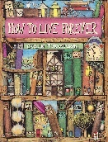  Stone Age Boy – Satoshi Kitamura  A selection of kennings poetry.  How to Live Forever – Colin Thompson  DK Find Out: Stone Age  Washing his disciples feet
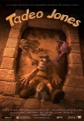  Summer 1  Tadeo Jones (Literacy Shed - Video)  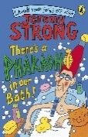  A selection of simile poetry.  There’s a Pharoah in our Bath  Jesus calms the storm | 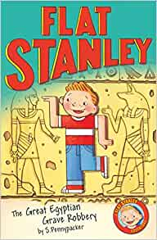  Summer 2  A selection of instructional texts (Ancient Egypt)  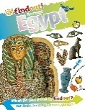  Flat Stanley: The Great Egyptian Grave Robbery  DK Find Out: Ancient Egypt  A selection of summer poetry  Christian communities are like bodies  Muhammed Ali  Jessie Owens
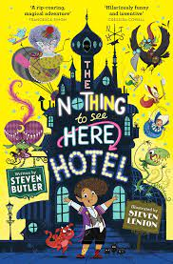
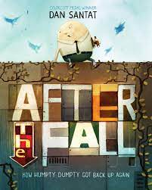
Recommended Reads
Fiction
The Nothing to See Here Hotel – Steven Butler & Steven Lenton
After the Fall – Dan Santat
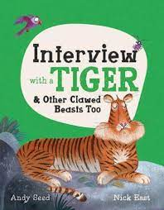
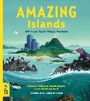
Non-Fiction
Amazing Islands – Sabrina Weiss & Kerry Hyndman
Interview with a Tiger - Andy Seed and Nick East
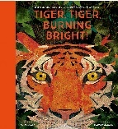
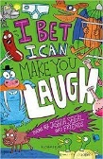
Poetry
I Bet I Can Make You Laugh – Joshua Seigal et al.
Tiger, Tiger, Burning Bright! – Fiona Waters & Britta Teckentrup

YEAR 4
Autumn 1  A selection of Olympics texts.  Greek Myths (Heracles, Icarus, Theseus, and the Minotaur)  Perseus and Medusa (play script)  Abraham and Sarah | 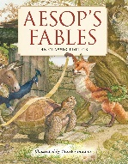  Autumn 2  Aesop’s Fables  A selection of various scripts.  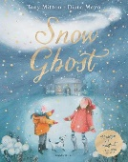  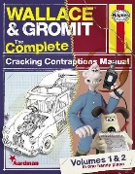  Cracking Contraptions  The Snow Ghost  Jesus born in Bethlehem  Amma, Tell me about Divali (H)
Spring 1  Beneath the Earth Poem by Malou Evans  Raging Volcano Poem by Malou Evans  A selection of non-chronological reports about Volcanoes.  A selection of newspaper reports about Vesuvius erupting.  A selection of informal letters.  Psalm 23 What is God like  Luoise Bourgeois | 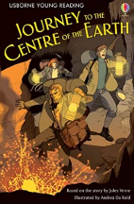  Spring 2  Journey to the Centre of the Earth : 1 (Young Reading Series 3, 2)  A selection of instructional texts.  A selection of Easter/Spring poetry.  Last Supper and the arrest in Gethsemane  Vanessa Nakate
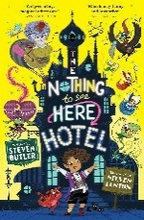  Summer 1  The Nothing to See Here Hotel  A selection of persuasive letters  Jesus teaches his first followers | 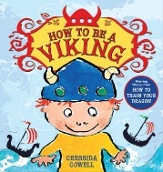  Summer 2  Historical fiction - Beowulf  How to be a Viking by Cressida Cowell  A selection of saving the planet poems  New Testament writers explain Christian belief about God  Michael Jordan
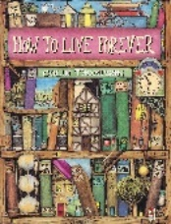
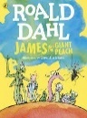
Recommended Reads
Fiction
How to Live Forever – Colin Thompson
James and the Giant Peach – Roald Dahl
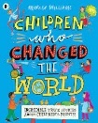
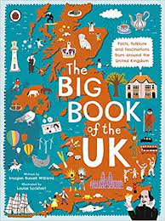
Non-Fiction
Children Who Changed the World – Marcia Williams
The Big Book of the UK – Imogen Russell Williams & Louise Lockhart
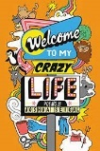
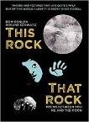
Poetry
This Rock That Rock – Dom Conlon & Viviane Schwarz
Welcome To My Crazy Life – Joshua Seigal & Chris Piascik

YEAR 5
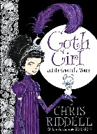  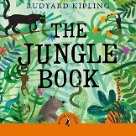  Autumn 1  A selection of migration texts.  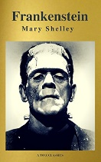  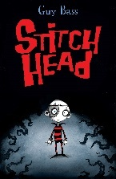  Jungle Book  Goth Girl  Stitch Head  Frankenstein  Faith in God  Stephen Hawking Albert Einstein  Mary Shelley | 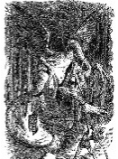  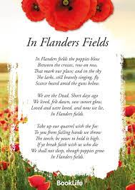  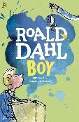  Autumn 2  Jabberwocky  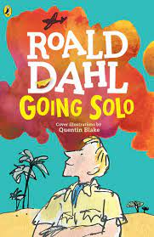  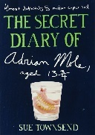  In Flanders Fields  Boy  Going Solo  The Diaries of Adrian Mole  Why God came into the World  My Dadima Wears a Sari (H)
  Spring 1  A selection of letters.  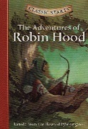  A selection of Newspapers.  Robin Hood (Folk Tales)  Covenant with God | 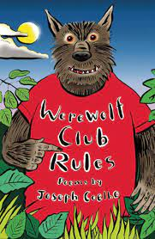  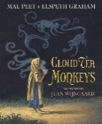  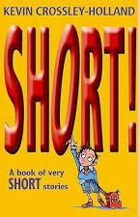  Spring 2  Werewolf Club Rules! (focus on Joseph Coelho)  Cloud Tea Monkeys – Mal Peet  Mysterious Traveller  Short! – Kevin Crossley-Holland  Jesus is put on trial
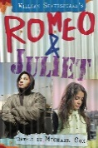  Summer 1  Shakespeare – Romeo & Juliet  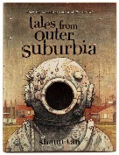  Tales From Outer Suburbia – Shaun Tan  A selection of letters, adverts, protest songs and speeches.  The Good Samaritan  Nelson Mandela | 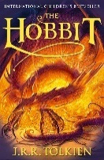  Summer 2  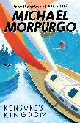  The Hobbit  A selection of poetry about the sea.  Kensuke’s Kingdom  Love in action  JRR Tolkien
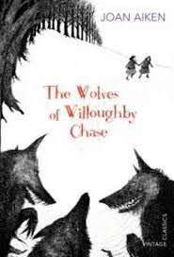
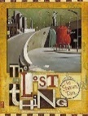
YEAR 5 – Recommended Reads

Fiction
The Lost Thing – Shaun Tan
The Wolves of Willoughby Chase – Joan Aiken
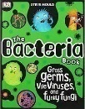
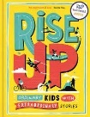
Non-Fiction
The Bacteria Book – Steve Mould
Rise Up – Amanda Li & Amy Blackwell
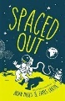
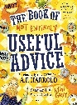
Poetry
Spaced Out – Brian Moses & James Carter
The Book of Not Entirely Useful Advice – A.F Harrold & Mini Grey

YEAR 6
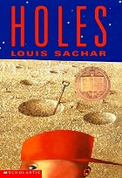  Autumn 1  Holes – Louise Sachar  A selection of non-chronological reports.  Mrs Katz and Kutz (J)  How can following God bring freedom and Justice  Malala Yousafzai | Autumn 2  Holes – Louise Sachar  A selection of war and remembrance poetry.  A selection of letters.  Why God came into the World  Anne Frank
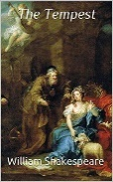  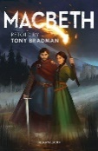  Spring 1  Macbeth Poetry  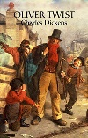  Shakespeare – Macbeth/The Tempest  Oliver Twist – Charles Dickens  10 Commandments  Charles Dickens, Jane Austen  Little Book of Hindu Deities (H) | Spring 2  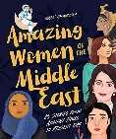  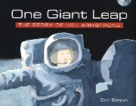  Amazing Women of the Middle East –Tarnowska Wafa  One Giant Leap – Don Brown  If – Rudyard Kipling  A selection of newspapers  The Crucifixtion/The death/Jesus has risen
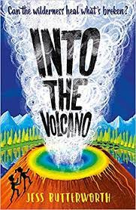  Summer 1  Into the Volcano – Jess Butterworth  A selection of Newspapers  A selection of natural disaster poetry  Jesus teaches his disciples | 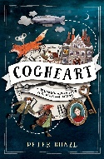  Summer 2  Cogheart – Peter Bunzi  Jabberwocky  A selection of interviews  St Paul teaches Christians about love
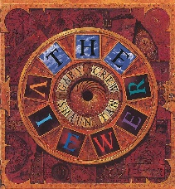
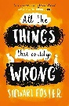
Recommended Reads
Fiction
The Viewer – Gary Crew & Shaun Tan
All the Things That Could Go Wrong – Stewart Foster

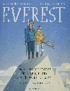
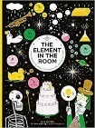
Non-Fiction
The Element in the Room – Mike Barfield & Lauren Humphrey
Everest – Alexandra Stewart & Joe Todd-Stanton
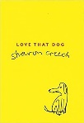
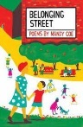
Poetry
Love That Dog – Sharon Creech
Belonging Street – Mandy Coe

Staff Recommended Reads
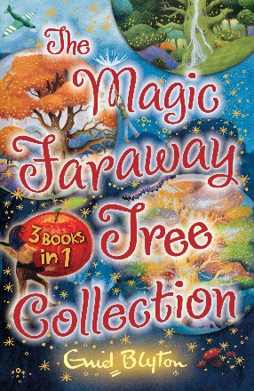
Miss Vardy
When I was a child, one of my favourite books was the Faraway Tree by Enid Blyton. I loved all books by Enid Blyton but I particularly enjoyed The Faraway Tree. This was because I imagined myself as one of the children who went to the forest and found the tree. I imagined that I had adventures and visited the lands at the top of the tree. As an adult, I love reading this book to children and listening to how much they enjoy the writing as much as I did when I was young.
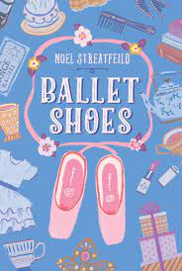
Mrs Rossi
My favourite book as a child was Ballet Shoes by Noel Streatfield. I used to do ballet and found the ballet and acting the girls did was fascinating. It was set in London, and that always seemed very exciting and very far away from Liverpool where I was brought up.

Mrs Fallon
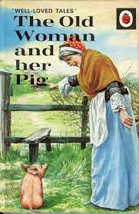
This ‘Old Women and Her Pig’ was a little Ladybird book that has remained a fond childhood memory of mine from when I was a little girl and it has stayed with me all my life.
It’s comical, poetical approach is a story of perseverance. All this old lady wanted to do was get home from the market with her new little pig which she’d bought with a old sixpence (2 & a half pence in our money today!) which she found whilst sweeping her home. Clearly not so lucky when it became apparent that the little piggy would not jump the stile so they could get home that night!
After approaching all kinds of options, finally the old lady finds a cat who is prepared to help and this unravels a humorous chain of events. The rollicking rhyme of this cumulative story and its cast of characters will have children chanting along til they get home tonight!

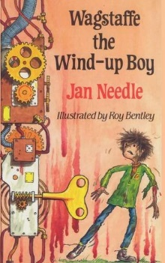
Mr Squire
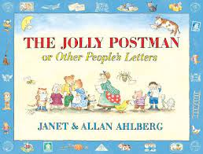
I loved book Wagstaffe the Wind-up Boy by Jan Needle when I was younger. I have no idea where it came from—it just appeared on the bookshelf at home. I was looking for something to read one day and I found it… it’s a cliché, but I literally couldn’t put it down! I was reading it one afternoon and my dad was calling me from the next room. He eventually found me and actually told me off for not listening to him—I was that lost in the book that I wasn’t aware of anything around me!
This book is really funny, gruesome and has a nice twist at the end too. The illustrations make the descriptions spring to life, I really cannot recommend this book enough!
Also, I have always loved The Jolly Postman and other people’s letters by Janet and Allan Ahlberg. As a young child the letters you could take out and unfold to read were amazing! Now, many year’s later I read those same letters and they make me smile—partly out of nostalgia but also because of the double meanings and extra details I now read and find in them! There are so many inside jokes in them! It’s another timeless book in my opinion. One you should definitely read!
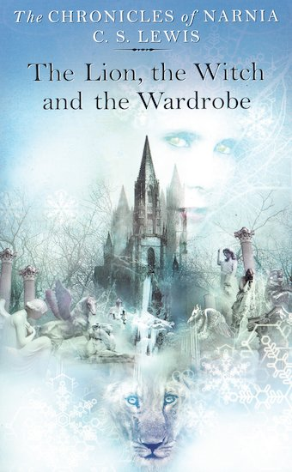
Mrs Reed
As a primary school child, I remember my teacher reading The Lion, the Witch and the Wardrobe to us. I looked forward to hearing the next chapter of the story every day. This fantastic book was written by C.S Lewis in 1950. Although it was written 72 years ago, children today would still enjoy it. I particularly liked the story because the children went through the wardrobe and ended up in a magical world which was full of interesting creatures and adventure. One of my favourite characters was Aslan because he was powerful and everyone looked up to him. It was truly amazing when he made all the creatures change from stone and come back to life. I felt as if I was there because of the fabulous description written by the author. He was also able to defeat the witch during a huge battle where good conquers evil. Additionally, I liked Lucy because she was a curious, truthful and kind-hearted girl whom I could relate to. This book taught me two important lessons; that looks can be deceiving and that two wrongs don't make a right. If you like magic, creatures and adventure then you would love this book too!

Mr Rutter
When I was a child my favourite book was called Peoples and Countries because it had lots of facts which I could digest. It was historical and geographical at the same time. I also loved that it was a big book, the bright and colourful pages made it attractive to my young self.
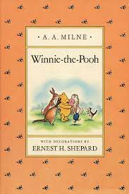
Mrs Steggall
When I was about nine my favourite book was Winnie the Pooh. I read it over and over again and knew the poems and songs off by heart. I can still recite 'Three Cheers for Pooh' now! I loved the humour, the strong characters and the friendships. I used to copy the illustrations with my paints. I loved honey and so did Pooh. Of course, this was before the days of 'Disney' Winnie the Pooh books- my book was the original! I took my book into school and my teacher read it to the class, one chapter a day, which made it even more special.

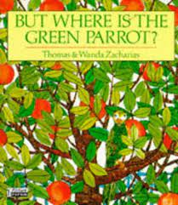
Mrs Breydin
This was my favourite book when I was really young. I loved trying to find the green parrot hidden on each page. I loved the illustrations in the book as they were so different form the more traditional illustrations of other books I was reading at the time.
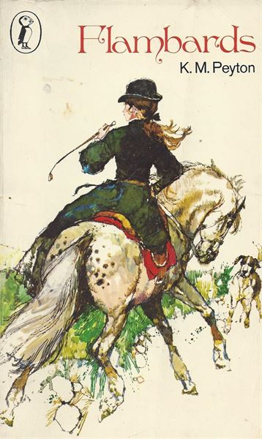
I really loved this book as I was really poorly when I read this and it really took my mind off being ill. It was the first story in a trilogy and I just couldn’t put it down. I was so keen to read the other books in the series that my mum went to the library to get them for me. These were just as enjoyable as this one.

